
PERTH COLLEGE

Trial WACE Examination, 2011

Question/Answer Booklet

MATHEMATICS
If required by your examination administrator, please place your student identification label in this box

3C/3D

Section One:

Calculator-free

Student Number: In figures

In words

Time allowed for this section
Reading time before commencing work: five minutes
Working time for this section: fifty minutes

Material required/recommended for this section

To be provided by the supervisor
This Question/Answer booklet
Formula sheet

To be provided by the candidate
Standard items: pens, pencils, pencil sharpener, eraser, correction fluid/tape, ruler, highlighters

Special items: nil

Important note to candidates

No other items may be used in this section of the examination. It is your responsibility to ensure that you do not have any unauthorised notes or other items of a non-personal nature in the examination room. If you have any unauthorised material with you, hand it to the supervisor before reading any further.

Structure of this paper

Section | Number of questions available | Number of questions to be answered | Working time (minutes) | Marks available
Section One:  Calculator-free | 7 | 7 | 50 | 40
Section Two:  Calculator-assumed | 12 | 12 | 100 | 80
 |  |  |  | 120

Instructions to candidates

- The rules for the conduct of Western Australian external examinations are detailed in the Year 12 Information Handbook 2011. Sitting this examination implies that you agree to abide by these rules.

- Write your answers in the spaces provided in this Question/Answer Booklet. Spare pages are included at the end of this booklet. They can be used for planning your responses and/or as additional space if required to continue an answer.
- Planning: If you use the spare pages for planning, indicate this clearly at the top of the page.
- Continuing an answer: If you need to use the space to continue an answer, indicate in the original answer space where the answer is continued, i.e. give the page number. Fill in the number of the question(s) that you are continuing to answer at the top of the page.

- Show all your working clearly. Your working should be in sufficient detail to allow your answers to be checked readily and for marks to be awarded for reasoning. Incorrect answers given without supporting reasoning cannot be allocated any marks. For any question or part question worth more than two marks, valid working or justification is required to receive full marks. If you repeat an answer to any question, ensure that you cancel the answer you do not wish to have marked.

- It is recommended that you do not use pencil except in diagrams.

Section One: Calculator-free [40 Marks]

This section has seven (7) questions. Answer all questions. Write your answers in the
space provided or on the spare pages included at the end of this booklet.

Working time for this section is 50 minutes.

Question 1 [4 marks]

Two sets A and B are such that P(A) = 0.5 and P(B) = 0.4.
Determine P(A 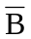) in each of the following circumstances:

- P (A B) is as large as possible. (1 mark)

- P(AB) is as small as possible. (1 mark)

- A and B are independent. (2 marks)

Question 2 [4 marks]

Consider the functions f(x) = 1 − x² and g(x) = 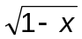

a) Determine the simplified equation of f o g (x) (2 marks)

b) State the domain and range of f o g (x) (2 marks)

Question 3 [3 marks]

Use the given graph of a derivative function f ʹ(x) to sketch a possible function f (x) on the
blank axes below.

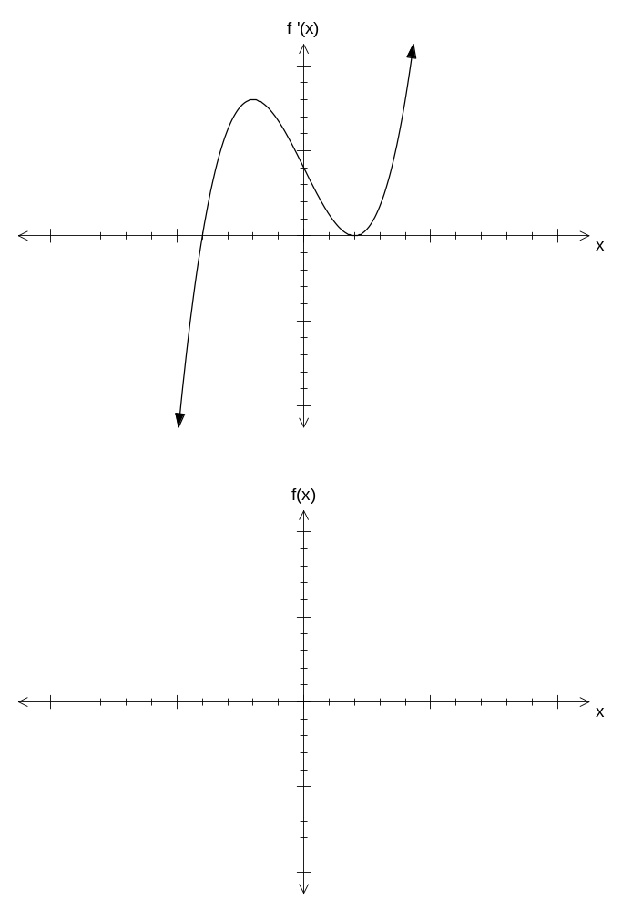

Question 4 [5 marks]

The diagram shows AC tangent to two circles at B and C. The centres of the circles
are located at E and D, and the radii of the two circles are x and 2x units respectively.
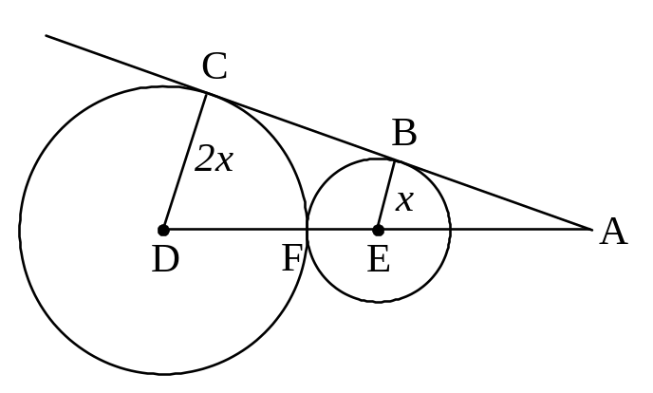
The two circles just touch each other at F.

a) Prove that triangle ABE is similar to triangle ACD (i.e. ΔABE~ΔACD); (3 marks)

b) Use the result from part (a) above to determine, in terms of x, the distance, AE, from the centre of the smaller circle to the point A.
(2 marks)

Question 5 [6 marks]
a) Simplify 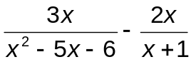 (2 marks)

b) Solve x + 4 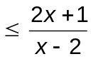 (4 marks)

Question 6 [11 marks]

a) Determine 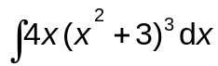 (2 marks)

b) Determine 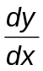for each of the following functions. Do not simplify your answers.

- y = 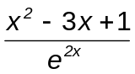 (2 marks)

ii) y = ( 2x² – 3x + 1 )⁴ (2 marks)

iii) (2 marks)

c) Determine the equation of the tangent to the function f(x) = (e^{x} + 1) ( x² – 2)
at the point (0, –4). (3 marks)

Question 7 [7 marks]

A function f (x) = x⁴ + ax³ + bx² + cx + 1 has a horizontal point of inflection at the point
(1, 2).

By considering f (1) = 2, the equation a + b + c = 0 is formed.

a) Use the first and second derivatives to generate two more equations involving a, b, and c.
(3 marks)

b) Use a method of elimination to determine the values of a, b, and c. (4 marks)

END OF SECTION ONE
Additional working space
Question number(s):

SECTION ONE:

Question Number | Available Marks | Your Mark
1 | 4
2 | 4
3 | 3
4 | 5
5 | 6
6 | 11
7 | 7
Total | 40

